**Ayesha Zubair**

**52916**

**Lab 9**

**Task 1:** Write shell script that reads 2 integer values from user and print their sum on screen.

**Code:**

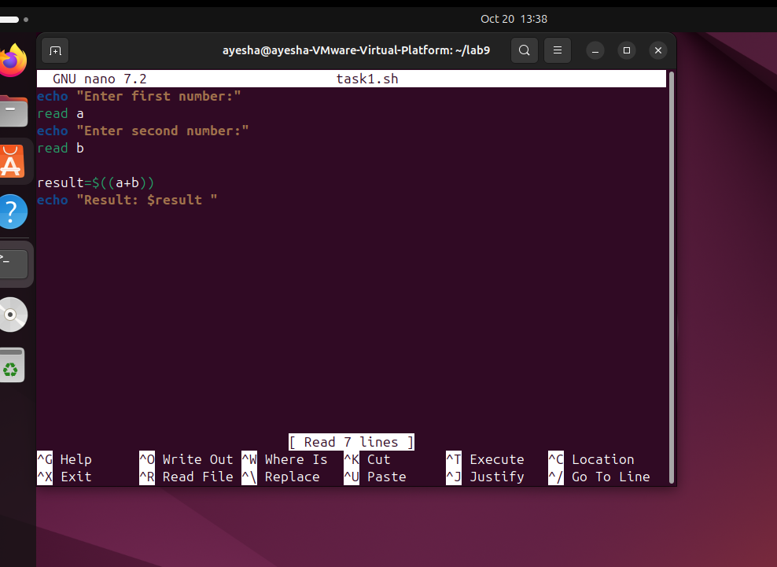

**Output:**

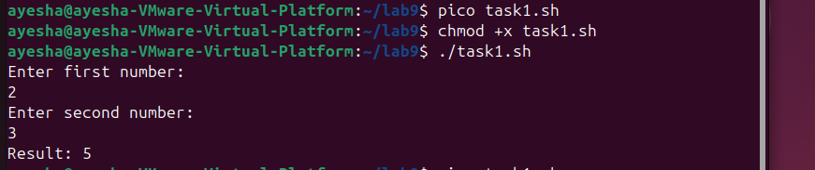

**Task 2:** Write shell script that defines 2 integers and one float value like

a=5

b=7

c=5.5

Perform multiplication of integers then divide with float.

and finally print result with four decimal places like 6.3636

You have to use pipe operator ( | ) to send variables to **bc** utility for arithmetic.

**Code:**

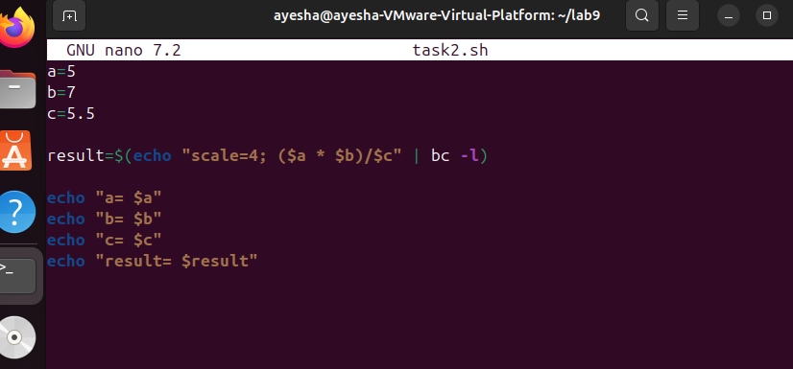

**Output:**

